Weekly update:

Simulation:

This week we worked on circuit simulations to evaluate the designs of the circuit we should use. We decided in a meeting that we would use this method to evaluate the circuit designs as we have time and cost constraints. We used multisim 14 to start performing simulations on simple circuits.

We started with the design known as the thickenator V2 ( <https://www.dropbox.com/s/x0xvr4qzj9fz5v1/inthinkeratormkIrev2_guide.pdf?dl=0> ):

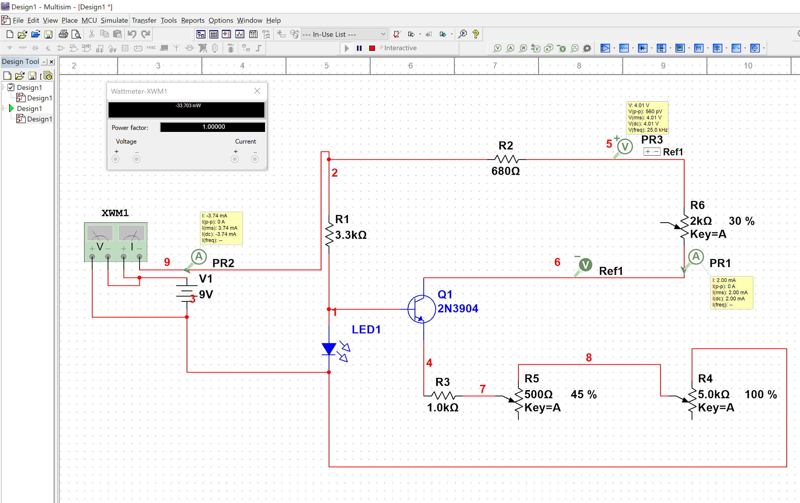

This circuit is commonly used in the DIY tDCS community and the results are very promising. One thing that might be changed is the potentiometer component. The final design may only have one resistor to produce a steady current for one montage.

Price analysis: Online documentation stated that this Design would cost about 10$ including electrodes, an enclosure and auxiliary materials. The main component (the transistor) costs 6 USD on amazon in packs of 100 (https://www.amazon.com/Laqiya-100Pcs-General-Purpose-Transistor/dp/B01M309DB3/ref=sr_1_3?ie=UTF8&qid=1543641415&sr=8-3&keywords=2N3904)

Power analysis:using simulation we found that this circuit would draw about 33.7 mW (3.74 mA).

Based on Duracell’s Datasheet (https://d2ei442zrkqy2u.cloudfront.net/wp-content/uploads/2016/03/MN1604_US_CT1.pdf) on their consumer 9V batteries, there is a 1 volt voltage drop for 2 milliamp current draw over 50 hours. We should then realistically expect that there will not be much of a voltage drop over a 40 minute dose.

Design 2:

This Design is also one used in the open source community, except it uses a voltage regulator instead of a transistor like the first design to manage the current, we found that this circuit, while simple does not supply a reasonable current. Though the current is in fact constant. We think more calculation might need to be done to see if there is a way to configure the voltage regulator so that it works.

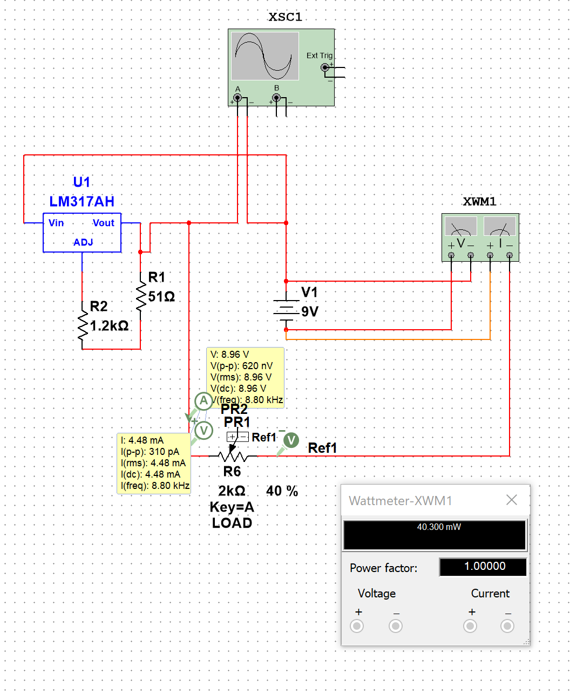

Power analysis: This circuit draws around 40 watts at 4.48 mA. It Draws more current than the first type and that makes sense because it pushes more current through the load (resistance of the head).

Note: the LM317 chip is used in many designs for DIY tDCS devices:

<https://www.youtube.com/watch?v=vtxfxKJI0VU&index=10&list=PLONJfHQUJtcUSap9TH5hYCrFCsjHTd5XT>

http://bobbytdcs.blogspot.com/2015/01/bobbys-tdcs-setup.html

Design 3:

This design will not amplify the voltage but use a high voltage source to drive a current source driven by an op amp. We will need to modify the design to make it work for our application.

Price: This circuit will probably cost more than using a transistor or a voltage regulator since the op amp will be an expensive part (about 57 cents for the UA741CP up to about a dollar for more precise amplifiers)

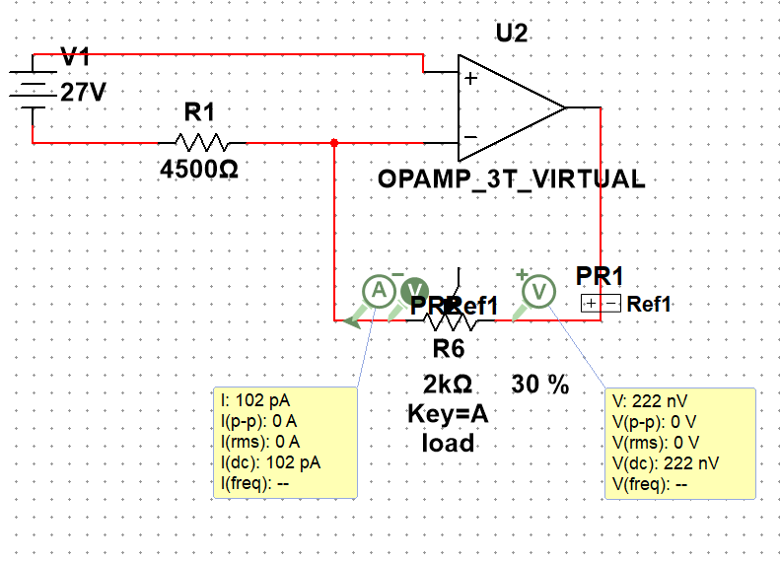

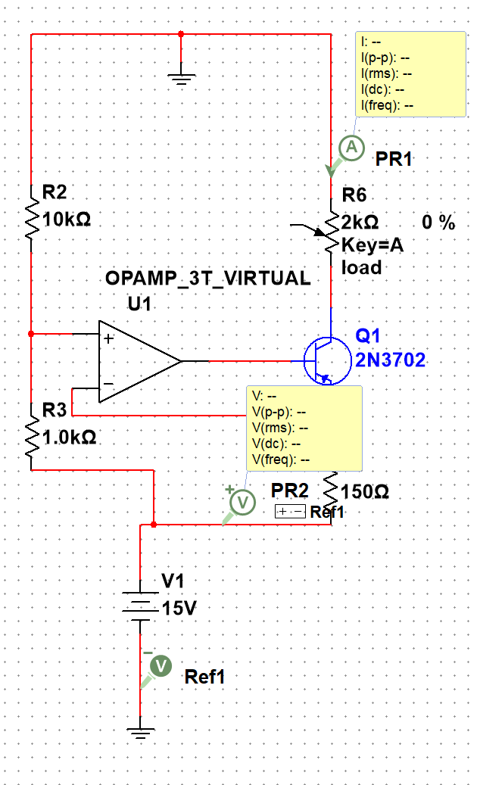

Timer circuit:

One possible way to dose the circuit is to use a 555 timer in monostable mode. We can choose RC to satisfy the equation T = 1.1 x R x C where T is 2400 seconds. Some we could use a 33 microfarad capacitor with a 66 megohm resistor in the following circuit:

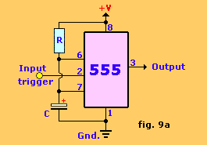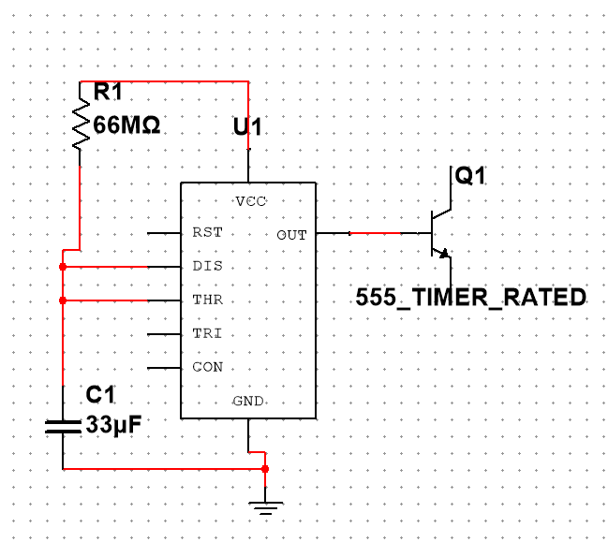

This output could then go to a NPN transistor in series with the battery, this would turn the circuit on when the input on the 55 is triggered and then turn off. Texas instruments 555 timers cost about 48 cents on texas instruments.

Voltage step up circuit:

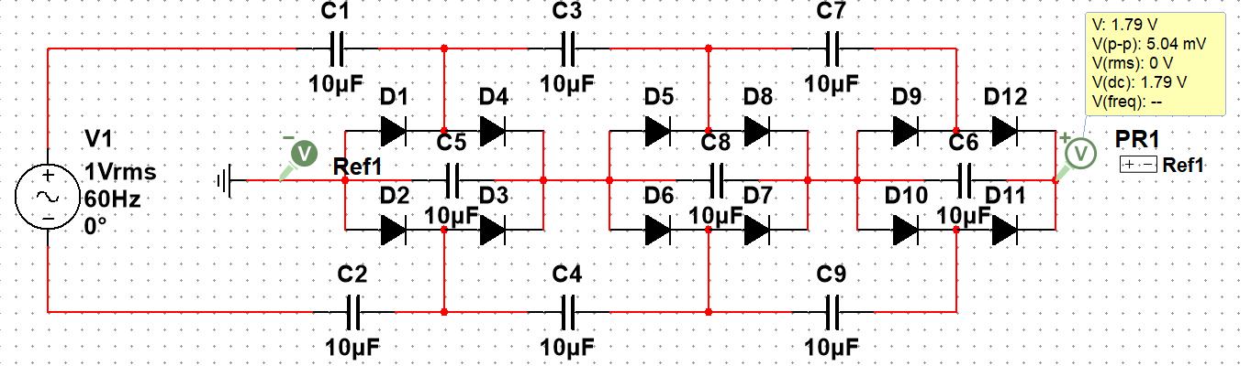

This circuit may be useful in stepping up the voltage and we tested it to make sure it would work to do so

Concept development:

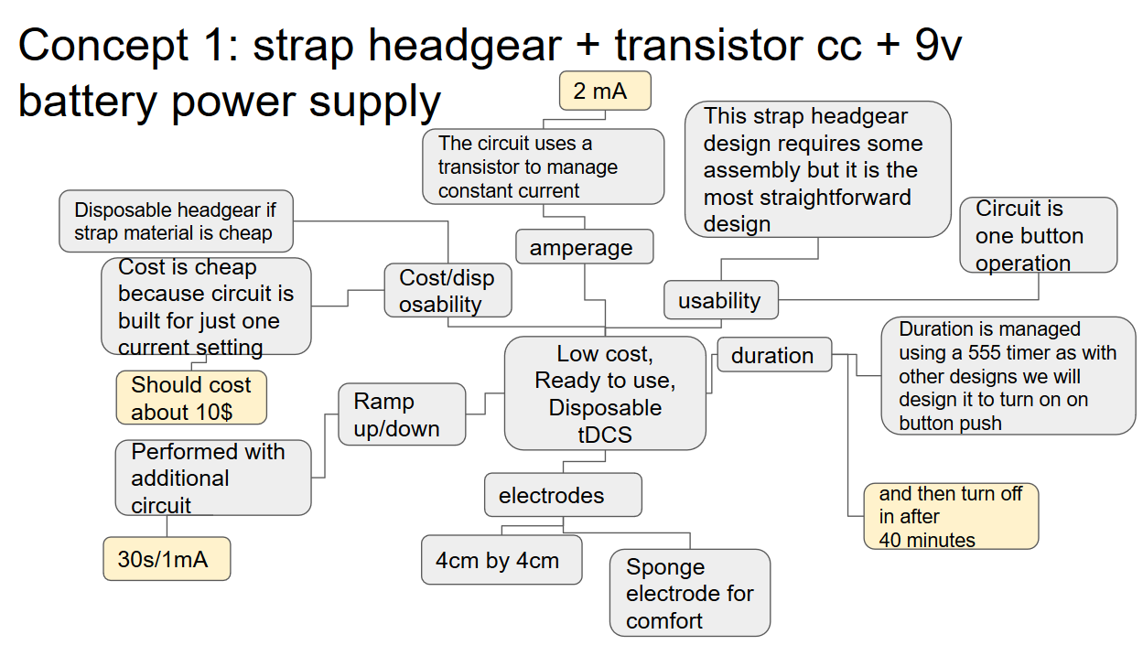

In this design a strapped headgear design with a circuit built using a single transistor and some passive components. This will lower the cost of the product. This design will also include a 555 timer to control dosage in terms of time, this design shows promising feasibility in hat the 555 circuit is well used in the diy and professional community. This circuit is also unique in that it proposes a headgear that uses snap together straps

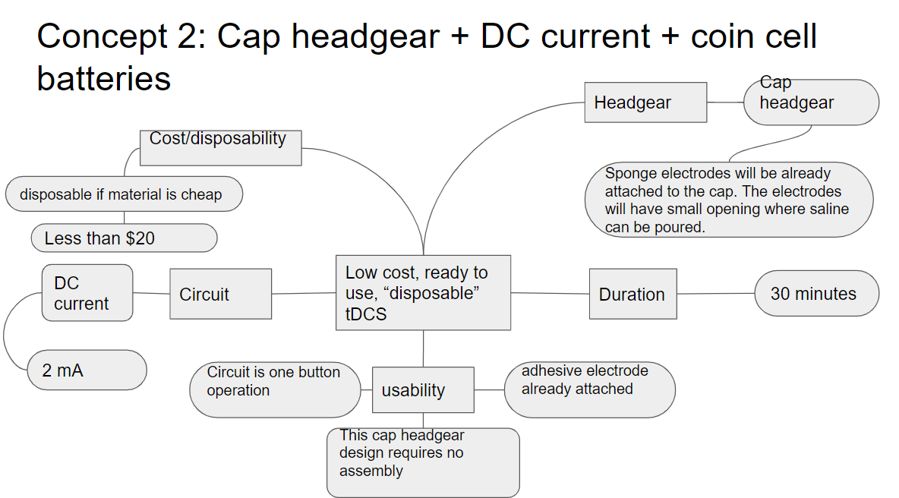

This design concept comprises of a hat with embedded tdcs device and electrode. The device cost rounds up to about $20. The design has no to little preparation process. User is able to use this device by removing the adhesive patching from the surface of the sponge, putting the hat on and start the stimulation.

The hat will be adjustable between 55 to 59 cm circumference. Sponge electrode will be pre-attached to the hat, with small opening for users to apply saline before stimulation. Constant-voltage system in the circuit allows the device to operate continuously regardless of battery health. After 30-minutes of use, the device will slowly ramp down the current and power off the device. The device is completely disposable after use.

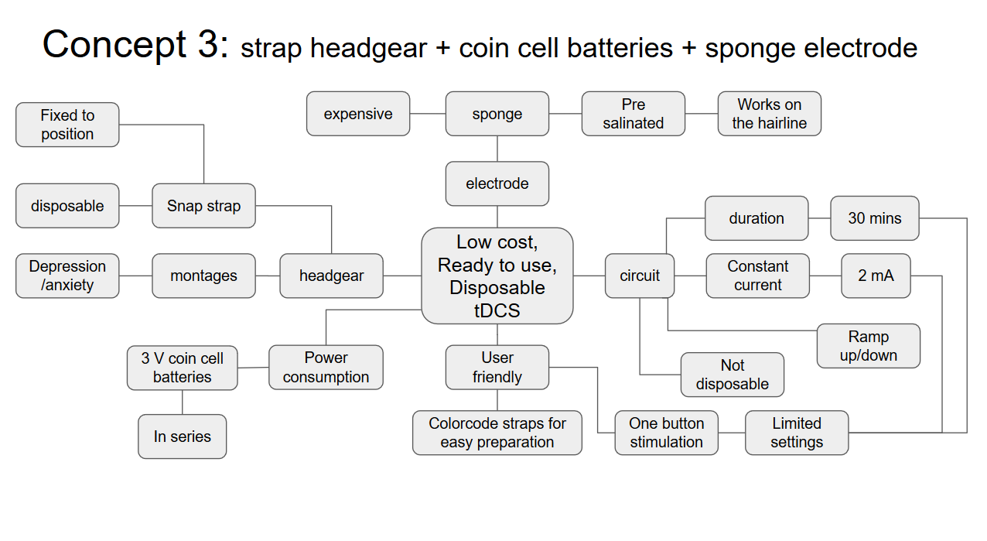

This concept is partially disposable design. The strap headgear and the sponge electrodes are disposable, and the circuit and the 3V coin cell batteries are reusable. The headgear is directed to assemble in a fixed position with color code, where it allows to stimulate specific montage of depression and anxiety. The electrodes are pre soaked with saline which allows them to conduct current through the hairline. The circuit is preset to stimulate in 2 mA current for 30 minutes with ramp up and down to avoid possible shocking.

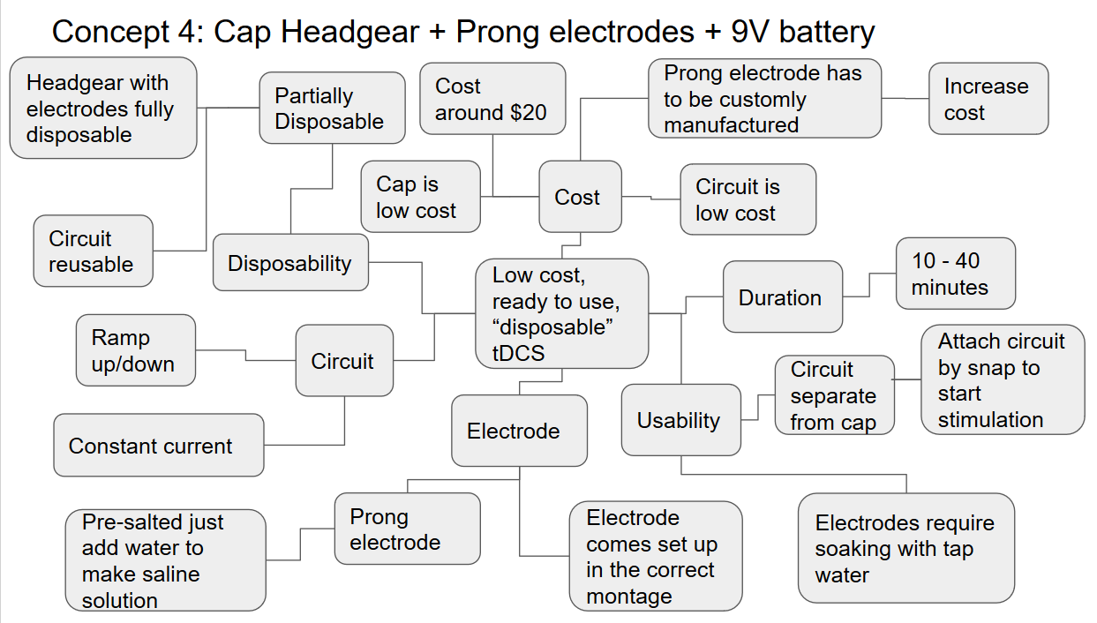

In this design prong electrodes are utilized, similar to the ones in the background. The prong electrode comes attached at the correct montage to the inside of the cap. The electrode is activated by applying tap water. The circuit comes in a separate container that is attachable via snap to the cap. The circuit is powered by a 9V battery that produces a steady current with a ramp up/down feature. The cap and electrode is fully disposable while the circuit is reusable.

···